**CENWP-OD-D 07/02/2023**

**MEMORANDUM FOR THE RECORD**

**SUBJECT: 23TDA06 *The Dalles Dam East Ladder Pacific Lamprey Tube Trap Mortality***

On Sunday morning 02 July 2023 CRITFC staff found one Pacific Lamprey mortality in one of the East Fish Ladder lamprey tube traps. The fish was collected at The Dalles Dam on 02 July for the CRITFC-Tribal translocation program. The cause of death is unknown. Photos of the fresh mortality were taken at the time of removal from the trap and are attached. The individual was scanned for PIT tags and frozen for potential future pathogen evaluation.

1. Species – Pacific Lamprey (*Entosphenus tridentatus*)
2. Origin – unknown
3. Length – 24.5”
4. Marks and tags – none
5. Marks and Injuries found on carcass – none
6. Cause and Time of Death – unknown
7. Future and Preventative Measures – none

*.*

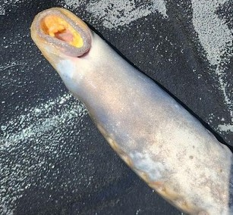

Sincerely,

Project Fisheries

